Hertford Regional College
Equality and Diversity
Annual Report
2020-21

Contents
Introduction 3
Single Equality Scheme 3
Our community 4
Post 16 provision 4
Demographics 4
Eliminate discrimination, harassment and victimisation 4
Foster good relations between different groups 5
Advance equality of opportunity 6
Promotion of Equality and Diversity across College and in teaching and learning 7
Leadership and Management 7
Our partners 8
Data relating to student participation 9
Our Staff 10
Performance against equality objectives 11
APPENDIX 1 14

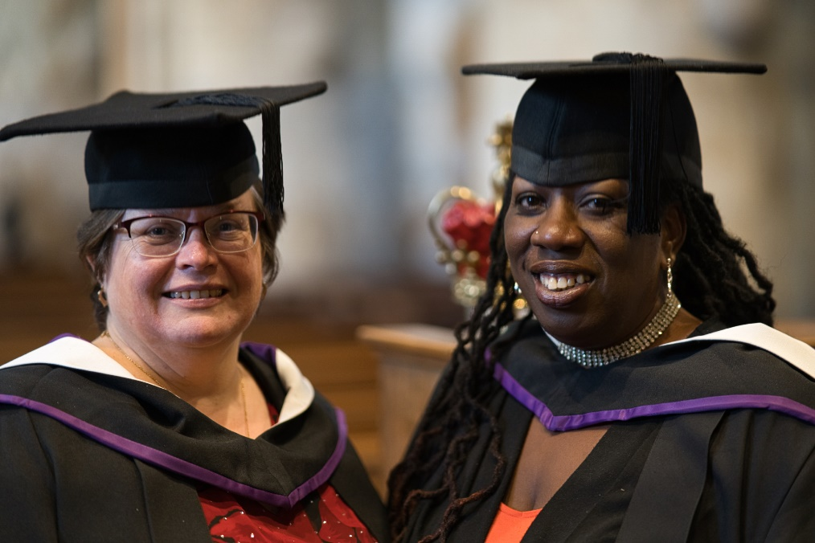

HRC Higher Education Graduation 2021
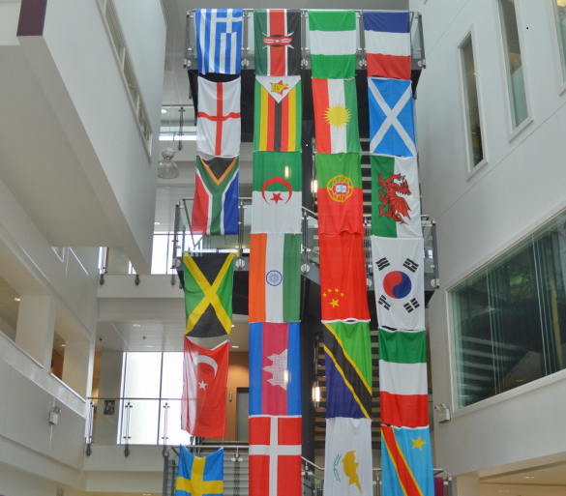

Introduction

This report demonstrates how Hertford Regional College (HRC) is meeting the public sector general and specific equality duties, and provides evidence that the College shows due regard to:
- Eliminating discrimination, harassment and victimisation
- Fostering good relations between different groups, and
- Advancing equality of opportunity and creating a truly inclusive environment for all stakeholders

It encompasses quantitative and qualitative data and provides a summary on progress towards the College’s equality objectives.

Single Equality Scheme

Hertford Regional College has a single equality scheme that sets out in detail its equality objectives and the manner in which it assesses its performance in this area. The scheme can be viewed by clicking on the link below:

Click here to access the Single Equality Scheme on our website (Please Select “Click here to read the HRC Single Equality Scheme”)

Our community

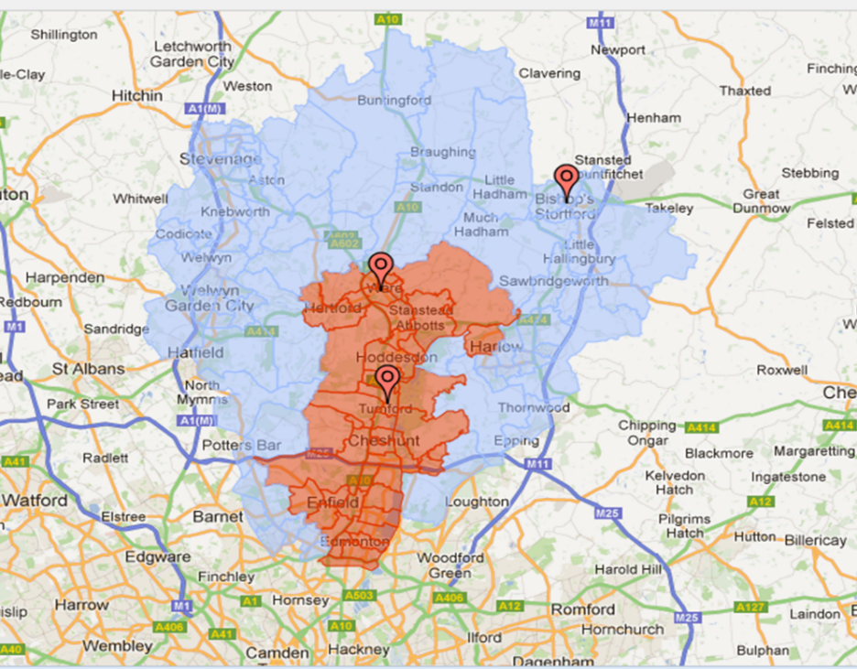
HRC is a medium-sized general further education College. It serves communities predominantly in East Hertfordshire, Broxbourne and North London. The College operates from its main campuses in Broxbourne and Ware, and also provides courses in a number of smaller community learning venues throughout the area. The majority of the College’s learners are drawn from the Hertfordshire local authority area, with the rest travelling from out-of-borough locations such as Enfield and North London.

Post 16 provision
The College provides a wide range of post-16 education and training including study programmes for 16- to 19-year-old learners, adult learning programmes, apprenticeships, higher education programmes, and provision for learners with high needs. The area in which the College sits is well served by sixth forms in local schools and academies.

Demographics

The College’s catchment area is large, diverse and relatively prosperous, although there are pockets of deprivation, particularly in the south of Broxbourne and in Enfield and North London.

Eliminate discrimination, harassment and victimisation

The safeguarding team and personal tutors have strong external multi-agency connections including close contact with agencies such as Child and Adolescent Mental Health Service (CAMH), The Anti Bullying Campaign Kidscape, Child Exploitation and Online Protection (CEOP), London Lesbian & Gay Switchboard, Muslim Youth Helpline, the NSPCC, social services, key workers, foster carers, police and child protection officers.

Induction and group tutorials are used to advise students about how to stay safe and to address issues that are common concerns with the post 16 age group. Students are encouraged to report bullying or e-safety issues through any member of staff, through their personal tutor or through Moodle.

All students are made aware of the limitations of confidentiality at the start of counselling appointments and 1:1s, and safeguarding awareness posters are displayed around college and in all classrooms.

All student surveys and complaints are analysed in relation to equality and diversity to ensure that any concerns in relation to equality and diversity are identified.

Foster good relations between different groups

Regrettably, our annual Diversity competition did not take place in 20/21 due to the national lockdown in term 2. The College enrichment team is presently reviewing options for this competition moving forwards. However, there were a number of other initiatives and events run last year to foster good relations between different groups. These included activities around Black History Month, celebration of Diwali, presentations around culture and religion awareness, an art competition focussing on holocaust awareness day, activities around LGBTQ+ awareness month and a foreign language week.

Art and Design LGBT Mural 2020

Advance equality of opportunity

The College has a number of services to advance equality of opportunity, including counselling, careers advice, financial support and Additional Learning Support. Examples of the impact of these services in 2020-21 include:

- In 2020-21 the college ran a virtual HE parents’ evening to raise awareness and aspirations within the college community.
- Over the second lockdown staff contacted over 150 vulnerable students on a weekly basis to check on their welfare.
- On a star rating of 1 to 5 students on average rated the careers support gained from advisors as 4.7.
- 98% of enrolments for High Needs learners achieved their qualification.
- 93% of learners in receipt of Additional Learning Support successfully achieved their qualification.

In the last Matrix Assessment report, it was noted that ‘Additional careers resources have been much welcomed and have increased outputs and outcomes. In turn these resources will help the College to fulfil the DFE (Department for Education) Careers Strategy guidelines, including the Gatsby benchmarks. From the cited developments over the last 12 months, it is evident that cross college IAG (Information, advice and guidance) practices are being strengthened with the careers programme and implementation plan refresher’.

In the last published Ofsted inspection report, it was noted that ‘Learners and apprentices receive good impartial careers advice and guidance. Most take advantage of the plentiful opportunities to understand their next steps and shape their plans through careers guidance services provided by a team of appropriately qualified careers advisers and appropriate promotion at tutorials and well-planned cross-college careers events’.

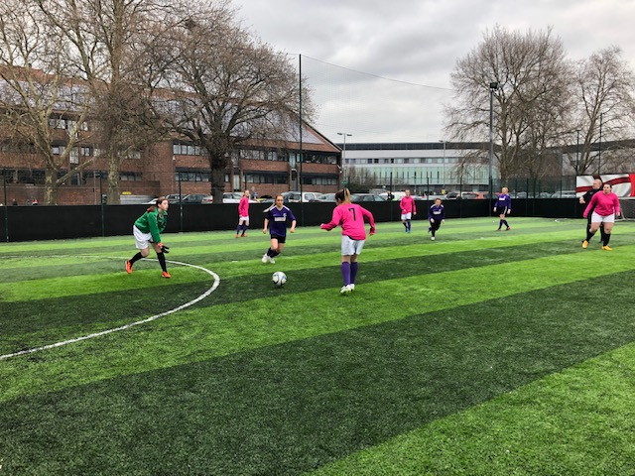

Promotion of Equality and Diversity across College and in teaching and learning

At HRC, students work well together and have respect for themselves and each other. Good promotion of equality and diversity across College results in a highly inclusive environment and effective embedding within the wider student experience. In particular:

- Comprehensive policies on bullying, harassment and discrimination are well understood and used to protect staff and students.
- Highly active Inclusion and Impact Task Group, with strong representation across all departments, promotes significant activity and impact on the student and staff experience. The group regularly monitors progress for different groups of learners where achievement gaps are identified, along with examining underlying reasons and taking relevant action to support learners. In 2020-21, this resulted in improved achievement rates for the large majority of EDIM (Equality and Diversity impact measure) categories.
- A full calendar of events promoting equality and diversity were run by the enrichment team.
- Support for students is permeated by the College’s commitment to equality and diversity. It is systematically embedded in the College calendar of events and challenged through partnerships nationally with Investors in Diversity and locally with community groups and employers.
- Training in equality and diversity is good and 99% of staff have completed E&D training; of those not completed, 2 are new staff in probation who will need to complete in order to pass their probation. E&D themes are effectively embedded into the wider staff development opportunities.
- An introduction to equality and diversity is included during the college induction event, with additional online training to be completed during the probationary period. Exploring Unconscious Bias workshops commenced in 2020-21. To date 82% of colleagues have completed, feedback has been positive and local actions are being worked upon.
- The College prioritises equality and diversity well by requiring all managers to embed EDIMS into their Quality Improvement Plan.

Leadership and Management

A strong line is taken to avoid discrimination, harassment and bullying. Student disciplinary and complaints are analysed to ensure that no group of learners are over-represented in terms of their ethnicity. The Disciplinary Policy has been recently reviewed and updated to ensure a greater level of positive engagement. An Exclusion Panel is convened in the case of any learner that is being excluded to ensure that all the evidence has been reviewed and that all stakeholders are clear on the action being recommended. Within individual departments there is proactive work around the organisation of positive teambuilding activities, and the rigorous and consistent application of policies relating to behaviour including bullying.

In the last published Ofsted inspection report, it was noted that ‘Leaders have established an inclusive environment for all learners where learners and staff exhibit high levels of respect and tolerance with each other’. Leaders and managers continue to focus on monitoring and where necessary closing any gaps in achievement.

Throughout 2020-21, regular monitoring of progress for different groups of learners where achievement gaps were identified in 2019-20 took place, ensuring improvement actions were identified, and that swift action was taken to reduce the variability in achievement rates between these different groups. This resulted in improved achievement rates in the large majority of EDIM categories, and the work around closing the achievement gap for the groups of learners who have achieved below the national average continues in 2021-22.

Construction Learners British Values Flag 2020

Our partners

We can only achieve an inclusive environment in partnership with our students, staff, parents, employers and community partners. We are fortunate in having many external relationships and work closely with them to our mutual benefit. These range from partnerships with statutory bodies like the police & health services to local businesses and charities.

Data relating to student participation

Participation
The table below shows the number of funded learner enrolments for each type of provision in 2020-21

Type of provision | 20/21
16-18 Study Programmes | 1779
Adults (19+) | 2044
Apprenticeships | 491
High Needs Learners (counted within the three categories above) | 155
School Partnerships | 54
Additional referrals from schools | 27
Higher Education | 272

The graphs below give some information about the characteristics of the E&T (education and training) funded enrolments.

Our Staff

Each year an analysis of the overall staffing profile is provided along with their participation in staff development activities. The objective of the analysis is to identify whether there are any particular areas of concerns or discrepancies in participation based on the protective characteristics identified and to take remedial action where necessary.

HRC’s Equality and Diversity Staffing Profile report for the academic year 2019-20 is provided as Appendix 1.

HRC Learners Celebrating Diwali 2020

Performance against equality objectives

Objectives were updated in 2019-20 and agreed by senior managers. Objectives are reviewed each year by the Equality & Impact Group. The progress against these objectives has been based on an analysis of the student cohort completing in 2020-21.

Updated Target:
Support all learners to ensure that they achieve their full potential. This will be done by monitoring the in-year performance and final achievement rates of learners against EDIM national averages and the overall College achievement rate.

- All EDIMs groups have performed above national averages with the exception of Pakistani learners (3 learners, 1 non-achiever resulted in this group being 18.2% below national average) and the ‘unknown’ ethnic group (12 learners, the group performed 1.6% below national average)
- In addition, whilst Black African (42 learners) achieved higher than national average rates, they were below the overall college achievement rate by -0.7%
- The achievement rate for Adult (19+) classroom based learning (when including English and maths) has declined by 3.0% since last year, and is now 0.5% below national average.
- Female learners in 20-21 outperformed males by 2.6% overall, which is the reverse of 2019-20 when males achieved higher than female learners by 0.3%, showing also that the achievement gap has widened.

Updated Target:
Actively promote and encourage greater participation of under-represented genders in curriculum areas where there is a clear gender bias.

- Staff in Childcare, Health and Social Care, and the STEM subjects continue to promote their courses to try and increase the participation levels of underrepresented groups.

Updated Target:
Monitor the in-year performance and achievement rates for 16-18 learners so that they continue their upward trajectory and remain above national average.

- The overall achievement rate for 16-18 learners when including English and maths improved for a fifth successive year. In 2020-21 it increased by a further 0.2% to 87.2%.

Updated Target:
Increase ethnic minority participation for apprenticeship starts by 15% over 4 years.

- The proportion of ethnic minority apprentices remains low and will continue to be a priority in 2021-22 (taken from Leavers 20/21, all apprentices including subcontractors)

 | 17/18 | 18/19 | 19/20 | 20/21
College Leavers | 269 | 272 | 301 | 247
White Leavers | 235 | 246 | 275 | 229
As % | 87.36% | 90.44% | 91.36% | 92.71%

Updated Target:
Maintain employee declaration to at least 95%.

- 100% declaration in 2019-20

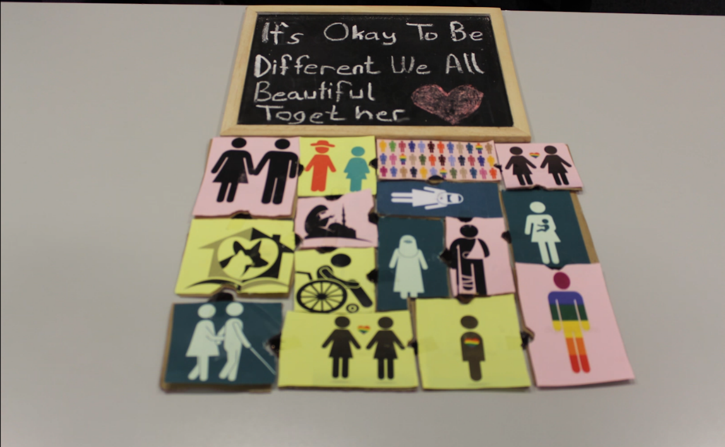
LLDD Learners Celebrate Inclusivity 2020

APPENDIX 1
HERTFORD REGIONAL COLLEGE
EQUALITY AND DIVERISTY STAFFING PROFILE
ACADEMIC YEAR 2020/21

- INTRODUCTION
The purpose of this report is to update the Impact and Inclusion group in relation to equality and diversity data relating to employees and candidates. During 2020/21, the college employed 335 staff and 20 hourly paid staff. We had 101 applications for vacancies advertised internally and externally.
In line with the College’s Resourcing Procedure, recruiting managers are not provided with candidates’ diversity information prior to interview. Candidates are shortlisted against the essential and desirable criteria set out in the job description and person specification. As we are a Disability Confident Employer to comply with our duties, we do make recruiting managers aware of any applicants declaring a disability.
To encourage a wide range of applications, the college advertisements are neutral in their design to discourage applications from all sections of the community and is opposed to stereotyping a role with images.

- GENDER PROFILE

2.1 Candidate data
The chart below shows that the college attracts a higher percentage of female applicants than males. This is representative of the gender profile for colleges where the employment of females is around 66% of the workforce. The proportion of female when considered against male candidates show that 72% of Women are hired against 32% Males, which shows that Female are more successful at interview. Female applicants – 62% vs Males 38%. There is a 16% drop in Male hired applicants when compared to 2019/20.

2.2 Staff data

The gender balance of salaried staff is identified in the chart below. This has remained static when compared to 2019/20.

Flexible working for both men and women to work part-time is equally available to men as it is to women and is highlighted at induction.

2.3 Senior Leadership Team and direct reports
Staff working within the senior team (SLT) and their direct reports shows a high percentage of females working at a senior level (59%). At an SLT level 67% are female.

3.0 DISABILITY PROFILE

5% of the workforce have disclosed a disability which has seen a 1% increase when compared with last year.

7% of candidates applying to work at HRC declared a disability which is an increase of 1.6% when compared with 2019/20

There were no candidates appointed whom had declared a disability.

- AGE PROFILE

All groups within the staff age profile has shown a slight increase (2% lower <30 to 2% higher 61+) when compared with 2019/20. The age profile of the staff employed is representative of the further education sector. We do not collect age data for applicants.

- Ethnicity Profile

The 2011 Census reported that the proportion of the total population that were in a minority ethnic group (i.e. not White-British) was 19.18%. The college workforce is generally representative by having 18% non-white-British workforce.

ETHNICITY | COLLEGE  ETHNICITY  PROFILE
 | %
Asian | 3
Black | 7
Mixed | 1
White British | 81
White other | 5
Do not wish to disclose | 1
Any other | 2

The overall ethnic minority workforce representation has remained static year-on-year
27% of candidates declared an ethnic minority background vs 73% White British. 12% of ethnic minority candidates were offered a role vs 88% White British.

- SEXUAL ORIENTATION
The college employs 82% of employees who have declared their sexuality as Heterosexual. The percentage of staff who identify as LGBTQ+ has remained constant at 2%.

- RELIGION
The religion profile does not show any significant changes from 2019/20.

- CONCLUSIONS AND RECOMMENDATIONS
Upon analysing the data there are some suggested management actions, detailed below
Declaration rates remain high and this will remain a priority when transitioning to the new HR System in April 2022.
LGBTQ applicants have increased when compared with last year.
Despite the number of Male applicants, female applicants appear to be more successful – worth investigating.
Despite the number of applicants declaring a disability, whilst they are invited to attend an interview if the minimum criteria is met, non-disabled applicants appear to be more successful – worth investigating.

Suggested management actions:
- Look at recruitment and selection in terms of gender profiles.
- Ensure accuracy of data transfer to new HR system in April 2022.
- Continue to remind staff of the value of declaring protected characteristic as they use new system and continue to sustain an organisation culture where colleagues feel safe to declare.
- Ensure inclusion remains a priority in the implementation of the People Strategy Action Plan.

